HPC-platform

Specifications document

Jelle Maas (479146)

Koen Janssen (451394)



# Abstract

Soon, the students from Delta will have their own high-powered computer, also known as the number cruncher. The goal of the number cruncher system is to give all Delta students the ability to easily send their resource-intensive workload, e.g., AI model training and media rendering, to this powerful computer. This could potentially save lots of time for the Delta students, for the number cruncher can do resource-intensive tasks much more efficiently.

The general idea is, thus, to create an easy-to-use system for Delta students, so they can submit their workloads to the number cruncher and finally get back their results. This while having a system that automatically manages the workloads on the infrastructure and software side.

# 

# Contents

**Abstract** **1**

**Contents** **2**

**Version History** **3**

**1 Introduction** **4**

**2 Operating system** **4**

2.1 Installation process 4

**3 Configuration** **5**

3.1 Wi-Fi 5

3.2 CUDA 5

3.3 Samba 5

3.5 VPN 5

**4 Management** **6**

4.1 Create user account 6

4.1 Retire user account 6

**5 Security** **7**

**Conclusion** **8**

**Glossary** **9**

**References** **10**

# Version History

| Date | Version | Author | Comment |
| --- | --- | --- | --- |
| 29.03.2022 | 0.1 | K. Janssen & J. Maas | Initial setup, wrote the introduction, installation process, configuration, management, and security. |
| 30.03.2022 | 0.2 | J. Maas | Reformatted introduction, wrote configuration and created users management |
| 30.03.2022 | 0.2 | K. Janssen | Updated security section |
| 04.04.2022 | 1.0 | J. Maas & K. Janssen | Finishing touches, add abstract, glossary, and references |
| 30.05.2022 | 1.1 | J. Maas & K. Janssen | Processed feedback points from stakeholder. |
| 31.05.2022 | 1.2 | K. Janssen | Updated references |

# 1 Introduction

This report describes the installation process and configuration of the HPC machine (also known as the number cruncher), including some important highlights. This document is there to inform others on how the HPC machine is currently configured and how it can be managed in the future.

Please note that when the specifications change, it is required to update this document accordingly with the changed attributes.

# 2 Operating system

GNU/Linux based OS was chosen as an operating system for its stability, and the majority of supercomputers run a GNU/Linux based operating system. Supercomputers are most often purposely built for scientific research, machine learning et cetera “500 most powerful supercomputers around the world, 52.8 percent were running the Linux operating system, whilst 17.8 percent of the leading supercomputers used the CentOS operating system.” (Alsop, 2021), and contains all the necessary packages for CUDA which is used for AI compute acceleration.

## 2.1 Installation process

On the first attempt, a Debian image was installed on the HPC, which then temporarily connected over Ethernet with a laptop. The laptop was set up to share the Eduroam Wi-Fi connection over Ethernet. Unfortunately, no way was found to get it working with stability with Debian's minimal installation.

On the second attempt, an Ubuntu Desktop 20.04 image was installed on the HPC, which then connected directly to the Eduroam Wi-Fi network. Since Ubuntu Desktop contains many redundant tools and utilities, they have been removed. After installing the operating system, Python, Anaconda, CUDA, NVIDIA drivers, and Samba were installed and configured.

# 

# 3 Configuration

## 3.1 Wi-Fi

Currently, the HPC does not have a proper Ethernet connection to the global internet. This connection remains to be set up by the ISSD. As a temporary solution, the Eduroam Wi-Fi network was used to provide the HPC with global internet communication. To facilitate this, a temporary user was created for authenticating with the Eduroam network. The users of the HPC have been notified about this.

## 3.2 CUDA

“CUDA is a parallel computing platform and application programming interface (API) that allows the software to use certain types of the graphics processing unit (GPU) for general-purpose processing, an approach called general-purpose computing on GPUs. CUDA is a software layer that gives direct access to the GPU's virtual instruction set and parallel computational elements, for the execution of compute kernels.” (Wikipedia contributors, 2022)

CUDA was installed and configured using the “GPU support” documentation page from Tensorflow. There were no instructions available for Ubuntu 20.04, so the instructions for Ubuntu 18.04 were used. These instructions can be found at the following link: [GPU support | TensorFlow](https://www.tensorflow.org/install/gpu#ubuntu_1804_cuda_110).

## 3.3 Samba

Samba is configured in such a way that each user can access their own Linux home folder over SMB to attach their remote home folder as network-attached storage on their local machine.

## 3.5 VPN

Currently, students are unable to access the HPC system outside the Fontys network because the HPC is connected with the Fontys network and only allows local communication.

To solve the issue mentioned above, a VPN connection may be set up, with which students can connect to the internal network of Fontys and have access to the HPC system. Preferably, this would be the existing VPN server from Netlab because it may be more convenient for the student since it is already used within Netlab.

# 4 Management

To make user management on the HPC machine as seem as possible, a toolkit of scripts was added created

## 4.1 Create user account

A script can be used to create new user accounts on the HPC. This script adds a user account of choice via the first argument, generates a secure password, changes the shell configuration and initializes Samba for file sharing. The script can only be executed by sudoers or root users and is located at the following path: “/opt/hpc/create-user.sh”.

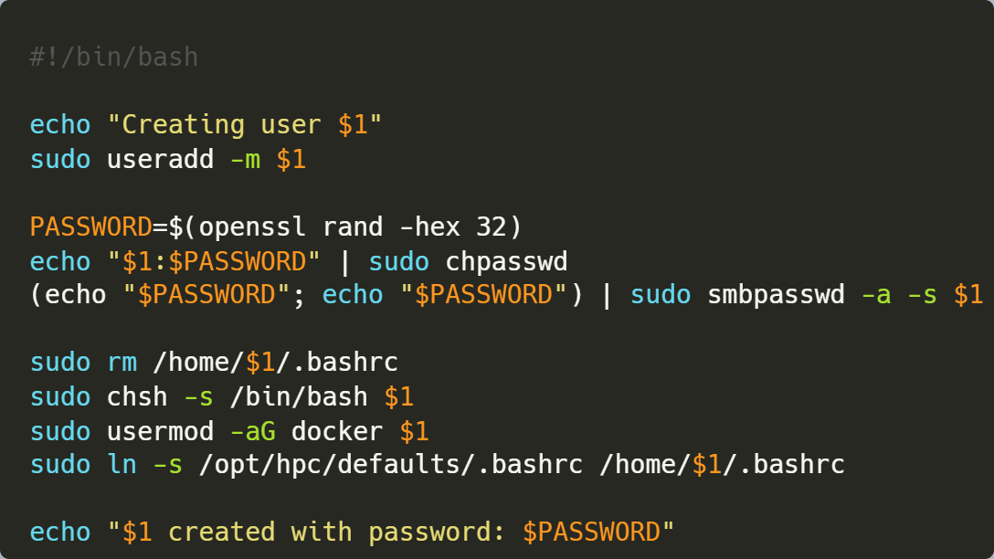

## 4.1 Retire user account

A script can be used to retire user accounts similarly to creating them. This script retires user accounts safely across all the installed services on the HPC machine. The script can only be executed by sudoers or root users and is located at the following path: “/opt/hpc/retire-user.sh”.

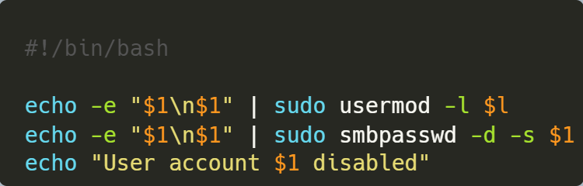

# 5 Security

For security, some basic security measures have been applied. These are the current security measures in place.

| *Security measure* | *Description* |
| --- | --- |
| Fail2ban | Protection against brute-force login attacks |
| Setting new user passwords to 32 characters |  |
| Password policy enabled for all user accounts | * Minimum of x characters * Password expiration |
| Uncomplicated Firewall (UFW) | Firewall protection |
| Unattended security updates |  |
| OpenSSH |  |
| Disabled root login |  |
| Faillog |  |
| Home folder encryption |  |

### 

# Conclusion

All specifications for the HPC system are described in this document, which makes it easier for new administrators to get acquainted with the system. It is up to the administrator(s) to document all newly installed and configured components here as well.

Based on the aforementioned specifications, the following conclusions can be derived:

* All installed components, including their configurations
* How external connections can be established
* The installation process of the system is described
* What kind of connection is used
* How security configuration is set up
* All management tools, which can be used to administer the system
  + Creation of new user accounts
  + Retiring of unused user accounts

# Glossary

| *Term* | *Explanation* |
| --- | --- |
| VPN | Virtual Private Network |
| UFW | Uncomplicated Firewall |
| HPC | High-Performance Computing |
| API | Application Programming Interface |
| GPU | Graphics Processing Unit |
| SSH | Secure Shell |
| SMB | Server Message Block |
| CUDA | Compute Unified Device Architecture |
| GPGPU | General Purpose Graphics Processing Unit |
| OS | Operating System |

# References

Alsop, T. (2021, October 20). *• Supercomputers OS share worldwide 2017-2021*. Statista. Retrieved May 31, 2022, from https://www.statista.com/statistics/565080/distribution-of-leading-supercomputers-worldwide-by-operating-system-family/

*CUDA*. (n.d.). Wikipedia. Retrieved May 31, 2022, from https://en.wikipedia.org/wiki/CUDA

*Install TensorFlow with pip*. (2022, May 20). TensorFlow. Retrieved May 31, 2022, from https://www.tensorflow.org/install/gpu#ubuntu_1804_cuda_110